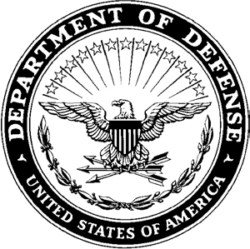
DEPARTMENT OF THE ARMY
HEADQUARTERS, AIRBORNE and RANGER TRAINING BRIGADE 10850 SCHNEIDER ROAD
FORT BENNING, GEORGIA 31905-5000

ATSH-RB 8 January 2026

MEMORANDUM FOR Airborne and Ranger Training Brigade

SUBJECT: [INSERT UNIT] Competitors for the Best Jumpmaster Competition

- The Soldiers listed below have been assessed and selected by the Commander to represent the [INSERT UNIT] in the Best Jumpmaster Competition:

  - Team 1

    - RANK last, name, first name (DODID)
    - RANK last, name, first name (DODID)
    - RANK last, name, first name (DODID)
    - RANK last, name, first name (DODID)

  - Team 2

    - RANK last, name, first name (DODID)
    - RANK last, name, first name (DODID)
    - RANK last, name, first name (DODID)
    - RANK last, name, first name (DODID)

- The Soldiers listed above have successfully completed a unit assessment that included the following events:

  - Army Fitness Test
  - 12-mile foot march in 3 hours with a minimum of 35lb rucksack, not including water weight.
  - Current and Qualified Jumpmaster

- The POC for this memorandum is the [INSERT DIV G3 (or BDE S3 if the unit is a separate BDE) POC information].

NAME
RANK, BRANCH
POSITION

02 February 2026 | Letter of Intent Due
02 March 2026 | Competitor Packet Due
16 March 2026 | ARTB releases by-name team list
06-07 April 2026 | Competitor Report Date
07 April 2026 | Competitor Day
08-10 April 2026 | Competition
10 April 2026 | Award Ceremony

