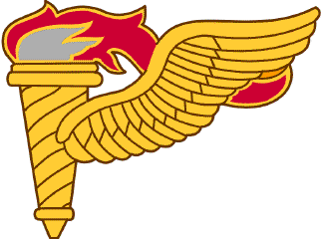

PATHFINDER
STUDY GUIDE
2014

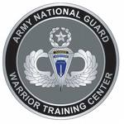

Sling Load Operations

Equipment Characteristics and Capabilities:

HELICOPTERS:

The Allowable Cargo Load (ACL): The maximum load capacity for a particular mission determines what the helicopter can lift. The ACL is based on the type of aircraft, age of the airframe, pilot experience, altitude above sea level, humidity, aviation unit's SOP and the temperature.

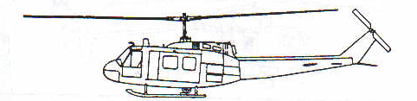 UH-1 IROQUOIS

APEX Requirements: A nylon point of attachment, such as a 3 ft apex ring or a basket hitch, or a polyester round sling, must be used to attach the load to the aircraft. In addition the 11k reach pendant can be used on the UH-1 series Aircraft since it can rotate 360 degrees. The cargo hook on the UH-1 is stationary and using a standard apex with a heavy load may bind on the hook, causing the hook to shear off.

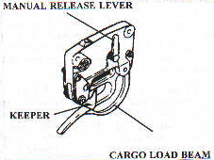
CARGO HOOK TENSILE STRENGTH: UH-1N - 5,000 LBS
UH-1Y - 5,000 LBS

(CARGO HOOK IS STATIONARY)
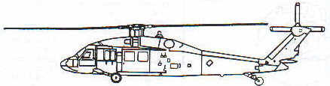

UH-60 BLACKHAWK

APEX Requirements: When using the 10k apex to secure an external load to the UH-60, the aluminum apex spacer MUST be used. This will center the apex on the cargo hook and prevent the apex from lifting the keeper during oscillation of the load, which would result in the load being jettisoned from the cargo hook. If the 25k apex is used, the spacer is not required. If the 25k apex spacer is used, the air crew cannot jettison the load if required and the cargo hook must be manually operated by the crew chief or ground crew on the LZ. NEVER use a nylon point of attachment such as a donut/web ring on a UH-60. The web ring will bind on the hook and prevent the crew from releasing the load in an emergency situation.
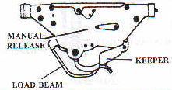
UH-60 CARGO HOOK SYSTEM

TENSILE STRENGTH: A MODEL - 8,000 LBS
L MODEL - 9,000 LBS
M MODEL-9,000 LBS

(CARGO HOOK ROTATES)

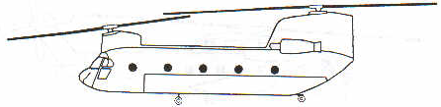
CH-47 CHINOOK
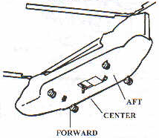
CH-47 MAIN CARGO HOOKS
LOCATION & TENSILE STRENGTH

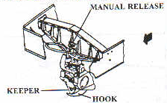
CH-47 CENTER CARGO HOOK (CARGO HOOK ROTATES)
D MODEL - 26,000 LBS
F MODEL – 26,000 LBS

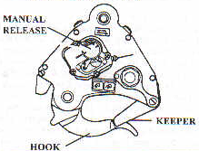

CH-47D/F FORE AND AFT CARGO HOOKS

(CARGO HOOK IS STATIONARY)

EACH - 17,000 LBS
COMBINED - 25,000 LBS

APEX Requirements: The CH-47 requires no special apex preparation and may accept all configurations to include 10K Apex with spacer & 25K apex with and without spacers and any nylon apex configuration, and field expedient attachments to include all clevises.

When attaching loads of different weights to multiple cargo hooks on the CH-47, such as attaching three cargo nets, attach them in the following manner:
1) Heaviest load on the center hook
2) Next heaviest (mid-weight) load on the forward cargo hook
3) Lightest load on the aft cargo hook.

When attaching loads that are being flown to different destinations to multiple cargo hooks on the CH-47, such as attaching three cargo nets with re-supply loads for spread out units, attach them in the following manner:
1) First to be delivered and lightest load on the forward cargo hook.
2) Second to be delivered and next heaviest (mid-weight) load on the aft cargo hook
3) Last to be delivered and heaviest load on the center hook

AERIAL DELIVERY SLINGS
TYPE XXVI MULTI-LOOP LINE

MAXIUM RATED CAPACITY

NUMBER OF LOOPS PENDANT LIFTINGPROVISION
2 8,900 LB 5,600 LB
3 13,500 LB 8,500 LB
4 17,800 LB 11,200 LB
6 27,000 LB 17,000 LB

LENGTHS

NUMBER OF LOOPS LENGTHS AVAILABLE
2 3’-9’-11’-12’-16’-20’-120’
3 60’-140’
4 3’-9’-11’-12’-16’-20’-28’
6 60’-120’

CLEVIS ASSEMBLIES:

- Large Suspension Clevis: Rated capacity of 12,500-lbs (pendant)(If 2 clevis are used as attachment points -15,750-lbs, for 3 as attachment points - 23,625-lbs, for 4 as attachment points - 31,500-lbs); 7,875-lbs (lifting provision).
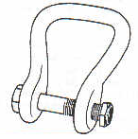
- Medium Suspension Clevis: Rated capacity of 6,250-lbs (pendant) 3,750-lbs (lifting provision). 2 attachment points - 7,500-lbs, for 3 attachment points - 11,250-lbs, for 4 attachment points - 15,000-lbs).

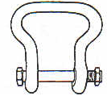
- 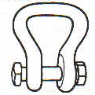Small Suspension Clevis: Rated capacity of 6,250 lbs (pendant) 3,750-lbs (lifting provision). 2 attachment points - 7,500-lbs, for 3 attachment points - 11,250-lbs, for 4 attachment points - 15,000-lbs);

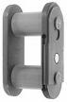

TYPE IV CONNECTOR LINK: Used in the construction of the 3-foot Apex Ring or to connect one ADS to another. Rated capacity of 12,500lbs.

10,000 AND 25,000 POUND CAPACITY SLING SETS: Both Sling Sets are similar, except for a few minor differences. Each set consists of four legs. Each of the legs has a rated capacity of 1/4th of the total capacity of the set.

10,000 AND 25,000 POUND CAPACITY SLING SET COMPONENTS
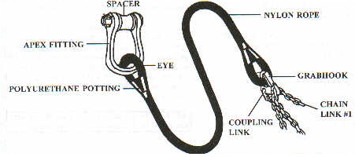
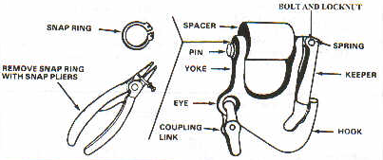
GRAB HOOK ASSEMBLY

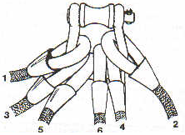
SLING LEG NUMBERING SEQUENCE

6 Component parts of the Apex fitting (10k and 25k)

- APEX SHACKLE
- APEX FITTING PIN
- APEX SPACER
- DRILLED BOLT
- CASTELLATED NUT
- COTTER PIN

CHARACTERISTICS

10,000 LB 25,000 LB
APEX FITTING
Material brushed aluminum gold steel
Pin size 1 1/8 inch diameter 1 1/2 inch diameter
Weight 4 1/2 lbs 10 lbs

NYLON ROPE
Rope color olive drab black
Length 12 feet 12 feet
Rope diameter 7/8 inch 1 1/4 inch

CHAIN
Links 110 - 115 86 - 88
Length 8 feet 8 feet

TOTAL WEIGHT 52 lbs 114 lbs

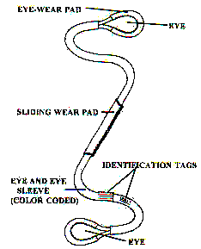

POLYESTER ROUNDSLINGS

POLYESTER ROUNDSLINGS

LENGTH COLOR LIFT CAPACITY BY HITCH TYPE WEIGHT
IN FEET CHOKED VERTICAL BASKET

8 GREEN 4,200 5,300 10,600 4

17 GREEN 4,200 5,300 10,600 10

8 YELLOW 6,700 8,400 16,800 5

17 YELLOW 6,700 8,400 16,800 11

30 RED 10,600 13,200 26,400 26

65 BLUE 17,000 21,200 42,400 75

70 BLUE 17,000 21,200 42,400 81

HLZ Operations/Air Assault Planning

Size of helicopter landing point: The size of the landing point will be decided by the aviation unit commander based on size/ type of aircraft, pilot/unit proficiency, whether the operation will take place during the day or at night, and atmospheric conditions.
- Tactical Considerations: The considerations that pertain to the actual mission of the unit being moved. These considerations are the responsibility of the ground unit commander (GUC), and his staff and include the following:

- The estimate of the situation using METT-TC (Mission, Enemy and friendly situations, Troops, Terrain and weather, and Time available, Civilians on the battlefield).
- Location of the objective from the tentative HLS.
- Size of the element being moved.

- Technical Considerations: The considerations that pertain to the technical aspect of selection and operation of a day or night HLS. These are the responsibility of the Pathfinder and are subdivided into the seven selection factors:

- Size of helicopter landing point: The size of the landing point will be decided by the aviation unit commander based on pilot/unit proficiency, size/type of aircraft, atmospheric conditions, and whether the operation will take place during the day or at night.

- Size 1 TDP - 25 meters in diameter (Small Observation)
- Size 2 TDP - 35 meters in diameter (Small Utility and Small Attack)
- Size 3 TDP - 50 meters in diameter (Large Utility and Large Attack)
- Size 4 TDP - 80 meters in diameter (Cargo)
- Size 5 TDP - 100 meters in diameter (Sling Loads, and Unknown aircraft)
- Size 6 TDP - 125 meters in diameter (Sling Loads using long lines)
- Size 7 TDP - 150 meters in diameter (Sling Loads using long lines, at night with NVG’s)

A/C Air Speeds

Air Craft | Cruising Speed | Max Speed
UH-1N | 110 KIAS | 120 KIAS
UH-1Y | 158 KIAS | 164 KIAS
UH-60L/M | 150 KIAS | 159 KIAS
SH-60 | 146 KIAS | 180 KIAS
CH-47D/F | 130 KIAS | 170 KIAS
CH-53E | 150 KIAS | 200 KIAS
CH-53K | 160 KIAS | 200 KIAS
V-22 | 220 KIAS | 250 KIAS

AIRCRAFT FORMATIONS

Landing formation and number of aircraft: There are nine standard aircraft formations:

- Trail 7. Heavy right
- Staggered trail left 8. Diamond (Most Secure)
- Staggered trail right 9. Vee
- Echelon left
- Echelon right
- Heavy left

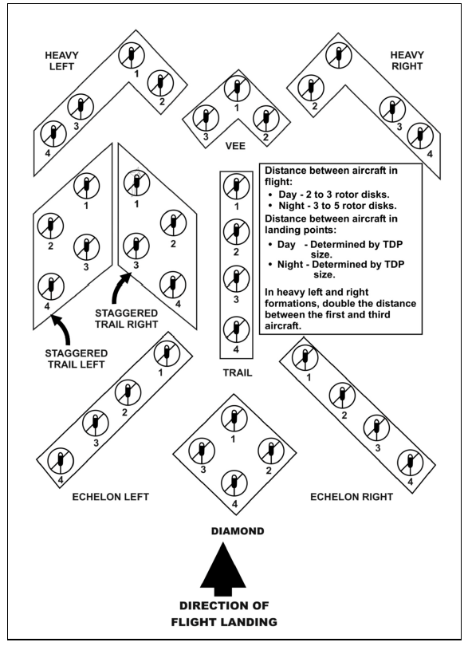

AIR ASSAULT PLANNING: Successful air assault execution is based on a careful analysis of METT-T, and a detailed, precise reverse planning. Five basic plans that comprise the reverse planning sequence are developed for each air assault operation. They are:

THE GROUND TACTICAL PLAN

THE LANDING PLAN

THE AIR MOVEMENT PLAN

THE LOADING PLAN

THE STAGING PLAN

There are three types of flight routes:

Restricted flight route: The aircraft is restricted as to their heading and altitude.

Flight corridor: The corridor reserves airspace around a flight route for AATF use, and prevents artillery, Tactical Air, and other elements from flying or firing through it when it is in use. The size of the corridor varies. Normally, they extend 200 - 300 meters on either side of the designated flight route, and 500 feet above or below the flight altitude. Authority to establish a flight corridor is obtained from the brigade and/or division commander(s). If it is necessary to restrict the operational area to only those aircraft directly involved in the air assault operation, a restricted area can be established by the airspace management element (AME), normally at Corps level.

Flight axis: The flight axis has a width (like a corridor) but does not have airspace reserved to a specified altitude (as does a corridor). The flight axis permits deviation laterally along the flight route. It gives the AMC a choice in selecting enroute formations, and freedom to alter direction without coordinating a new flight route.

DZ Operations

THE EIGHT DROP ZONE SELECTION FACTORS

There are eight drop zone selection factors considered when determining the suitability of a drop zone. The Drop Zone Support Team Leader (DZSTL) must be able to advise the ground unit commander on the suitability of the drop zone. There is no selection factor of more importance than the others. They all must be taken into consideration equally.

- Airdrop Airspeed
- Drop Altitude
- Type of Airdrop
- Method of Airdrop
- Obstacles
- Access
- Adequate Approach and Departure Routes
- Size of Drop Zone

- AIRDROP AIRSPEEDS: The aircraft airspeed will determine the amount of time the aircraft will fly over the drop zone. The slower the aircraft flies, the greater the number of jumpers or amount of equipment the aircraft can deliver. Airdrop airspeeds are measured in knots indicated airspeed or KIAS.

Airdrop Airspeeds (KIAS)
TYPE OF AIRCRAFT | DROP SPEED
UH-60 Blackhawk | 50 to 70 knots (Planning 70 knots)
CH-47 | 65 to 75 knots (Planning 70 knots)
C-23 Sherpa | 90 to 110 knots (Planning 105 knots)
C-130/C-17 (personnel/door bundles) | 130-135 knots (Planning 130 knots)
C-130 (CDS/Equipment/Combination) | 130-140 knots (Planning 140 knots)
C-17 (CDS/Equipment/Combination) | 140-150 knots (Planning/Optimum 140 knots)
C-17 Heavy Equipment | Planning 150 knots

USAF Fixed Wing Airdrop Airspeeds Personnel/Equipment (KIAS)
TYPE OF LOAD | C-130 | C-17
Personnel & Door Bundle Static Line | 130 | (130-135) 130
CDS/Combination & Equipment/Combination | 130-140* | 145-+/-5
Heavy Equipment | 140 | 150
Free Fall (Free Drop) | 140 | 145-+/-5
High Velocity CDS | 130-140* | 145-+/-5
Wedge | 130-140* | 145-+/-5
Ahkio Sled | 130-140* | 145-+/-5
CRRC (Combat Rubber Raiding Craft) | 130-140* | 145-+/-5
HSLLADS | In Route Airspeed

NOTE 1: * Used when gross weight is above 120,000 pounds. For combination drops, use the higher airspeed KIAS. A combination drop exist when different aircraft in a formation are dropping different types loads during the same pass over the drop zone or when different types of loads are exiting the same aircraft during the same pass over the drop zone.
- DROP ALTITUDE: Drop Altitude is measured from Above Ground Level (AGL). This is from the highest field elevation on the drop zone to the drop aircraft. However, some drop aircraft may request the drop altitude in Mean Sea Level (MSL) as measured from sea level. To calculate, take the field elevation and round it up to the nearest 50 feet. (e.g. 537 feet becomes 550 feet), then add the drop altitude in feet AGL.

550 ft. field elevation
EXAMPLE: Field Elevation = 537 feet roundup to 550 feet + 800 ft. drop altitude AGL
1350 MSL
Drop Altitudes
Rotary Wing & STOL Delivery Altitudes:
Personnel |  | Day or Night |  |  |  |  | 1500 Feet AGL
Bundles |  | Day |  |  |  |  | 300 Feet AGL
 |  | Night |  |  |  |  | 500 Feet AGL
LCLA |  | Day |  |  |  |  | 150 Feet AGL
 |  | Night |  |  |  |  | 150 Feet AGL
NOTE: If the rotary wing aircraft is flying 90 KIAS or faster the aircraft can drop personnel as low as 1250 Feet AGL.
USAF Fixed Wing Delivery Altitudes Personnel: |  |  |  |  | Planning Drop Altitude 1000 Feet AGL
Combat Operations (War) |  |  | Determined Jointly by Airborne and Airlift Commanders
Tactical Training |  |  | 800 Feet AGL
Basic Airborne Training |  |  | 1250 Feet AGL
SATB-P |  |  | 500 Feet AGL
USAF Fixed Wing Delivery Altitudes Door Bundles: |  |  |  |  |  | Planning Drop Altitude 1000 Feet AGL
Type of Parachute |  | Altitude C-17 |  |  |  |  | Altitude C-130
G-14 |  | 300 Feet AGL |  |  |  |  | 300 Feet AGL
T-10 Cargo |  | 300 Feet AGL |  |  |  |  | 400 Feet AGL
CDS Delivery Altitudes for C-17: |  |  |  | Planning Drop Altitude 600 Feet AGL
Type of Parachute | Number Parachutes or Containers |  |  |  |  |  |  | Airdrop Altitude
G-14 | 1 or 2 Containers |  |  |  |  |  |  | 300 Feet AGL
CDS Delivery Altitudes for C-130: Planning Drop Altitude 600 Feet AGL
Type of Parachute | Number Parachutes or Containers |  |  |  |  |  |  | Airdrop Altitude
G-14 | 1 or 2 Containers |  |  |  |  |  |  | 400 Feet AGL

USAF Fixed Wing Delivery Altitudes Heavy Equipment: |  |  | Planning Drop Altitude 1100 Feet AGL
Type of Parachute | Altitude C-17 | Altitude C-130
G-12E | 550 Feet AGL | 550 Feet AGL

USAF C17 Dual Row Delivery Altitudes Heavy |  |  | Planning Drop Altitude 1200 Feet AGL
Type of Parachute | Altitude C-17
G-11D | 1200 Feet AGL
G-12E | 1000 Feet AGL

USAF Fixed Wing Delivery Altitudes JPADS: |  |  | Planning Drop Altitude 10,000 Feet AGL
 |  | MINIMUM DROP ALTITUDE 3,500 Feet AGL
NOTE 1: Combination drops will use the highest airdrop altitude. A combination drop exist when different aircraft in a formation are dropping different types loads during the same pass over the drop zone or when different types of loads are exiting the same aircraft during the same pass over the drop zone.

NOTE 2: Minimum airdrop altitude for heavy equipment using the 5000-pound parachute release is 1000 feet AGL or by parachute type (which ever is higher).

3. TYPES OF AIRDROP: There are three types of delivery for airdrop items. They are low velocity, high velocity, and free drop. The method of delivery will normally determine the location of the control center. The primary difference between the methods of delivery is the type of parachute used or the lack of a parachute and the loads being delivered.

Low Velocity: Utilized for sensitive equipment and personnel drops. The canopy attached is used to slow the rate of decent to prevent damage to equipment or injury to the jumper.

High Velocity: The chute is designed to stabilize the load and reduce the rate of descent to a magnitude, which ensures acceptable landing shock.

Free Drop: Used for non-sensitive items only. No parachute is attached to the load

NOTE 1: When determining the suitability of the drop zone and considering method of delivery, caution should be taken when using high velocity or free drop around built up areas or airfields because risk of damage to buildings or airstrips.

4. METHODS OF AIRDROP: The type of load and the method it exits the aircraft will determine the amount of time it takes for the load to exit based on drop zone type.

Personnel and Door Bundles: This type of airdrop load self-exits, is pushed, or is skidded from the paratroop/aircraft door or aircraft ramp.

Personnel:
On all drop zones allow one second for each jumper to exit the aircraft. The one-second interval begins after the first jumper exits the aircraft.
For example, 10 jumpers require 9 seconds to exit the aircraft.

Door Bundles:
On GMRS and VIRS drop zones allow three seconds for each door bundle to exit the aircraft. The three-second interval begins after the first bundle exits the aircraft.
For example, 3 door bundles require 6 seconds to exit the aircraft.

On CARP drop zones door bundles are treated the same as personnel. For CDS and Heavy Equipment, the time requirement between loads is already factored into the minimum CARP DZ sizes found in AFI 13-217.

NOTE 1: There is no set amount of time to wait in between exiting bundles and personnel, however the jumpmaster team must ensure all bundles have been exited from the aircraft and that no unsafe condition exist before starting to exit personal in accordance with FM 3-21.220 chapter 10. Under no circumstances will bundles and personnel ever exit the aircraft simultaneously.

Gravity: The aircraft maintains a “nose-high” attitude (if required) and in-flight release of load restraint allows the load to roll out of the aircraft. A rigging system may be used to initiate and accelerate load movement.

Extraction: An extraction parachute pulls the load from the cargo compartment.

5. OBSTACLES: The DZSTL is responsible for conducting a reconnaissance and declaring obstacles on and near the drop zone.

Obstacles to personnel: Any feature, either natural or man-made that would pose a hazard to the jumper or prevent the jumper from accomplishing his or her mission.

Obstacles to equipment: Any feature, either natural or man-made that may hinder the recovery of the load or cause damage to a load.

Three Primary Obstacles:

TREES: 35 feet or higher impeding recovery of personnel or equipment. (35 feet is the distance from the top of a personnel parachute to the harness.)

WATER: 4 feet deep or deeper AND 40 feet wide at the widest point, within 1000 meters of any edge of the DZ. The DZSTL can declare any body of water a water obstacle.

POWER LINES: For the purpose of this publication, all restrictions apply to aerial power lines operating at 50 volts or greater.
1. Power lines present a significant hazard to jumpers. Jumpers can sustain life threatening injuries from electric shock and/or falls from a collapsed canopy.
2. To reduce this hazard, first attempt to site DZ so no power lines are located within 1000 meters of any DZ boundary.
3. If power lines are located within 1,000 meters of any boundary, coordinate with the Power Company to shut off power NLT 15 minutes prior to TOT.
4. If power cannot be interrupted, the flying mission commander, aircrew, and jumpmaster must conduct a risk assessment of the mission. Include as a minimum; type jump, jumper experience, aircrew experience, ceiling, and surface/altitude wind limits required to approve, suspend, or cancel the operation. To further minimize risks, consider altering the mission profile to raise/lower drop altitudes, change DZ run-in/escape headings, or remove inexperienced jumpers from the stick. If possible, mark power lines with visual markings (lights, smoke, or VS-17 panels).
WARNING: At no time will military personnel attempt to climb power line poles to position or affix markings to wires or poles.

6. ACCESS: Avoid major obstacles to personnel and equipment between the drop zone and the objective. Ensure that adequate routes are available for equipment recovery.

7. ADEQUATE APPROACH AND DEPARTURE ROUTES: Routes for the aircraft both into and away from the drop zone must be considered.
* No-Fly areas.
* Obstacles to the aircraft, e.g. TV towers, high-tension lines, etc.
* Terrain higher than the drop zone.
* Enemy situation and location.

8. SIZE OF THE DROP ZONE:
Verbally Initiated Release System (VIRS) size dictated by FM 3-21.38
Ground Marked Release System (GMRS) size dictated by USASOC Reg. 350-2
Computed Air Release Point (CARP) size dictated by AFI 13-217

POINT OF IMPACT (PI) LOCATIONS

For C-130 CDS drops the PI will be a minimum of 200 yards from the leading edge of the drop zone and centerline, 250 yards at night. C-17 CDS drops will be a minimum of 225 yards from the leading edge, centerline, 275 yards at night. For personnel drops the PI will be a minimum of 300 yards from the leading edge of the drop zone and centerline, 350 yards at night. For heavy equipment drops the PI will be a minimum of 500 yards from the leading edge of the drop zone and centerline, 550 yards at night.

MEAN EFFECTIVE WIND

Mean effective wind is the average wind from ground level to drop altitude. It is measured by using the Pilot Balloon (PIBALL). If piball capabilities are not available then surface wind will be used. If you have communications with the aircraft, it is beneficial to the mission if you transmit the MEW to the aircrew before the first pass. It will assist them in calculating an accurate release point.

PIBALL circumferences are as follows:

-10 gram for day: 57 inches
-10 gram for night: 74 inches
-30 gram for day: 75 inches
-30 gram for night: 94 inches

AIR FORCE AIRCRAFT FORWARD THROW:

FORWARD THROW DISTANCES FOR
FIXED-WING AIRCRAFT
LOAD |  | C-130 | C-17
Personnel or Door Bundle |  | 229 M (250 YDS) | 229 M (250 YDS)
Heavy Equipment |  | 458 M (500 YDS) | 640 M (700 YDS)
CDS |  | 503 M (550 YDS) | 663 M (725 YDS)
TTB |  | 147 M (160 YDS) | 147 M (160 YDS)
NOTE: To convert yards to meters, multiply yards by 0.9144.
To convert meters to yards, divide meters by 0.9144.

Forward throw for personnel and equipment using STOL or rotary-wing aircraft. To determine forward throw for STOL or rotary-wing aircraft, divide the drop speed of the aircraft in half. This yields the forward throw in meters. For example, an aircraft flying at 70 knots would have a forward throw of 35 meters.
EXAMPLE: 90 knots drop speed = 45 meters forward throw.

Max Surface Winds
Type Of Load | (Knots)
Personnel (land) | 13
Personnel (water) | 17
Equipment without ground disconnects | 13
Equipment with ground disconnects | 17
CDS using G-12 parachutes | 13
CDS or door bundles using G-13 or G-14 parachutes | 20
Simulated airborne training bundles | 25
High-velocity CDS/high altitude airdrop resupply system | None RResatreRestrictions
Free Drop | None Restrictions

